What are Constructor?
Special types of methods that we have in java which doesn’t have the return type
Constructor can have all access specifier
It should have the same name as class name
It can be both parametrized and Non parametrized

Note :
- In order to call constructor we just need to create an object
- Constructor overloading is Possible
- Constructor inherit is not possible.
- But using super calling statement we can achieve ex: super();
- This calling statement used to call from one constructor to another constructor within the same class
Super keyword:

Used in java only in the case of method overriding to call parent class implementation together with child class implementation

27-March-2025
>Final keyword

Applicable for below

1) Methods---- > Any method which is final cannot be overridden
2) Variables--- > Any variable which is final in nature will never ever be able to change its value
3) Class------- That means no one can inherit you (we should write final keyword in parent class , writing final keyword in child class-> not good)

Concrete Class |  | Abstract class
Concrete classes are those classes which has only concrete methods in them | >Any class which has abstract methods are called as abstract class.  syntax:  abstract class One  {  abstract void add();  }
 | >Any abstract class can have the combination of both concrete methods as well as abstract methods.

Concrete Method | Abstract Methods
>Any method which is concrete will have the method implementation  Example: Any method which has Implementation. | >Any method which doesn’t have any implementation [means method body] is called as Abstract method
Syntax:  static void add()  {  }  void subtract()  {  } | Syntax:  abstract void add();  >Abstract methods will always be non -static.  >Abstract methods need to be overridden

>Interface
It is use in Java to achieve 100% abstraction.
It consists of only abstract methods.
Interface can be created with a keyword called interface.

Syntax:
interface Amazon
{

}
>Just because interface consist of only abstract methods there is no need to write abstract in front of it.
>By default, all the methods in interface are public in nature.
>Any variables present in interface are by default public final and static in nature.

Relationships:

Class to | Interface >> | Implements
Abstract class to | Interface >> | Implements
Interface to | Interface >> | extends
Interface to | Class >> | Not Possible

Abstract Class | Interface
1. We cannot achieve 100% abstraction | we can achieve 100% abstraction
2.We cannot achieve multiple level inheritance | We can achieve multiple level inheritances
3. in AC we can have both methods like AM and CM | In Interface we can have only AM's
4. Abstract class can inherit the class | Interface can never inherit a class
5. Class can inherit the abstract class with the keyword called extends | class can inherit the interface with the keyword called implements
6. All the methods are not by default public | all the methods in a interface are by default public
7. All variables present here are not by default public, static and final | All the variables present here are by default public static and final
8. Abstract class can be created with a keyword called abstract | Interface can be created with a keyword called interface
9.  abstract class Google  {  } | EX:  interface Amazon  {  }

Interface example

Package ab53;

Interface One
{
Void method1();
Void method2();
}

Interface Two extends One
{
Void method3();
Void method4();
}

Public class ClassInterface3 implements two

{

Public Static void main(String[] args)

{

}

Public void method1(){

}

Public void method2(){

}

Public void method3(){
}

Public void method4(){
}

Multiple level Inheritance

//package

Interface one{

}

Interface second{
}

Public class Classs123 implements one,second ////to achieve multiple level Inhert via Interface concept

{

Public static void main(String[] args)
{}

}

Abstraction :
Hiding the implementation and exposing only what is required is called as abstraction.
This can be done in 2 ways:
1) Abstract Class-We can achieve 0 to 100% abstraction
2) Interface-We can achieve only 100% abstraction

Access Specifier for Classes And Interfaces:
private | Not Applicable
default/package | Possible
protected | Not Applicable
public | Possible

----------------------------- -----------------------------------------------^--------------------------------------------

String :

String a= “keerthivasan”;

a.length(); ---------- to check the length of the string it will return a int value

a.toUpperCase(); - Change string to uppercase it will return a string

a.toLowerCase(); - Change string to lowercase it will return a string

a.trim() ; -> it will remove spaces from starting & end of the string

- It won’t remove spaces in the middle of the string

a.equals(“ ”) to compare the equality of the two strings

a.equalsIgnoreCase(“ “) ------

a.contains(“ “) ----------- will check the string contains particular value

a.concat(“. “). ----------- it will merge the string

a.substring( s ); -------------- inside substring if we give index number it will take char from there to till last /// single parameter

a.substring( start index ,end Index) ------

for example string is “Keerthivasan Krishnamoorthy devi kavi”

if I want only keerthivasan out from the string we can go with substring with two parameter

a.charAt( 0) ; --------------will return char

a.indexOf( ‘ ‘) ; ---------- will return int (number)

a.lastIndexOf(‘m’). ---------- will return int

a.isEmpty();----------------------- will return Boolean

a.repeat() ;---------------------

JRE –version should be 17 or 21 > it is supporting Jenkins also

Is/has -----will return Boolean type

character & char ----------Both are different

Interger & Int -------------- Both are different

Mutable ------it is changeable

Immutable ------- It is unchangeable.

String ---ImMutable

--------------------------------------------------------------------------------------------------------------------------

tocharArray();

example : string b =”Keerthi”

b.tocharArray(); /// O/P = [k,e,e,r,t,h,i]

String s=”K e e r th I”

s.toCharArray() ; //// O/P ===. [k, ,e, ,e, r, ,t,h, ,i]

Array

- Use to store homogenious values
- they follow indexing
Syntax:
datatype []variable=new datatype[size];
or
datatype variable[]=new datatype[size];

String []name=new String[3];//declaring
name[0]="student1";//initiing
name[1]="student 2";
name[2]="student 3";

boolean [] answer=new boolean[3];
answer[0]=true;
answer[1]=false;
answer[2]=true;

Example program:

public class string {
public static void main(String[] args) {
String[] sb=new String[3];
sb[0]="keerthi";
sb[1]="vasan";
sb[2]="kavi";
for(int i=0;i<3;i++)
{
System.out.print(sb[i]);
}
System.out.print(Arrays.toString(sb));
}
}

O/P
keerthi
vasan
kavi
[keerthi, vasan, kavi]

String[3]
Now the string size is three , if we assign more than that we will be getting below exception

java.lang.ArrayIndexOutOfBoundsException:

WAP to accept the values of array at runtime in String datatype

Length();

Anything comes under parentheses is called as Method above one is a method

Length;

Predefined variable

Scanner sc=new Scanner(System.in);
String[] str=new String[sc.nextInt()];
for(int i=0;i<str.length;i++)
{
str[i]=sc.next();
}
System.out.print(Arrays.toString(str));
}

Now Str.length is predefined variable

O/p
2
kee
rthi
[kee, rthi]

String --------------- > we have to use length() method

If it String arrays class ---- > we have to use length - - global variable

WAP to copy one array into another array

input=[1,4,6,8]
output=[1,4,6,8]

Features | String |  |  | StringBuffer | StringBuilder
Introduction | Introduced in JDK 1.0 |  |  | Introduced in JDK 1.0 | Introduced in JDK 1.5
Mutability | Immutable |  |  | Mutable. We can modify string without creating new object | Mutable
Thread Safety | Thread Safe |  |  | Thread Safe | Not Thread Safe
Performance | Can be slower for many concatenations |  |  | Synchronized | Not Synchronized

What all concepts will be useful for Automation Testing:
List vs Set
Interfaces
Abstract methods
non static method
Polymorphism
class
Object
2 dimensional array
Map
Try and catch
throws
this kwyord
Looping concepts

Collection:

Framework in Java which can be use for adding,deleting,updating or fetching the data.
Collection is interface in nature.
It has many classes and interfaces in it.
Collection framework was originated in java version 1.2
Collection framework is divided in 2 packages:
a) java.util.Collection;
b) java.util.Map;
Collection can add the elements in the form of objects

>Collection is interface

>Collections is classes

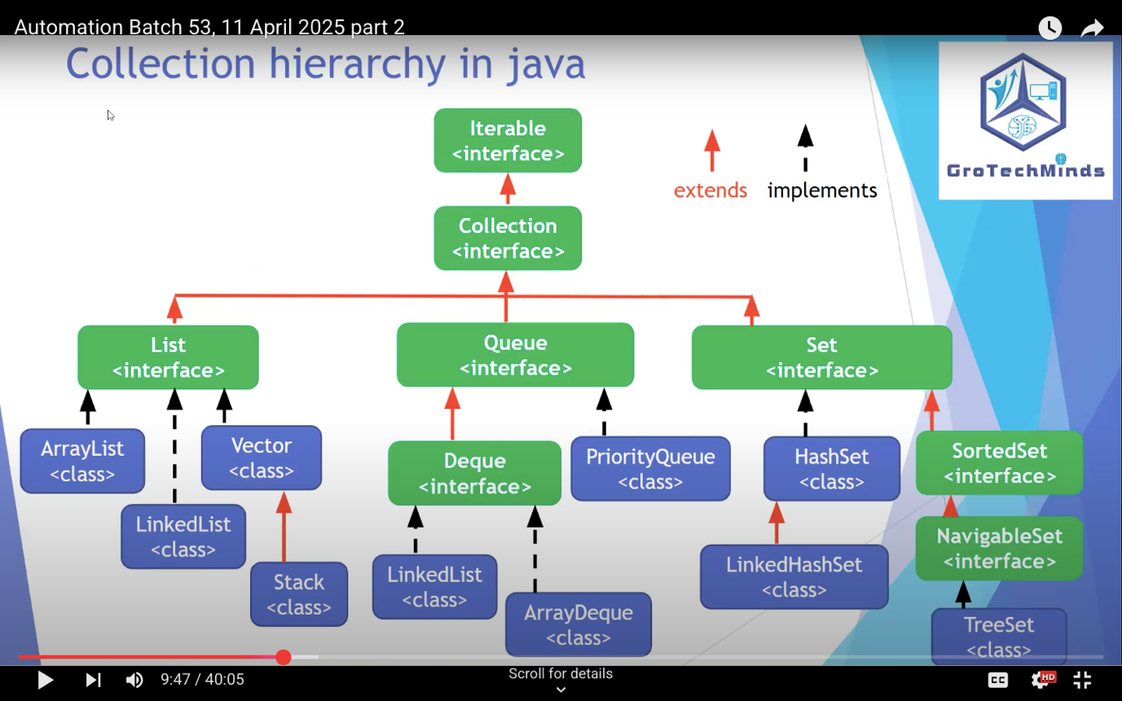

All green are interfaces

All blue are Classes

1)class can Inherit interface - >possible
2) Interface can’t Inherit classes -> not possible

Upcasting:
Converting the child class object into super class object

Object o1=new Classname(); Implicit Syntax (upcasting)

Object o2=(Object) new Classname(); Explicit syntax (Upcasting)

Example;

Collection c1= New Arraylist();

C1. ->> all related to collection method will come

Object means > byte,shot,int

Array drawback :
1)Fixed size in array,, but in collection we can overcome this drawback
2) Array has homogeneous value & but collection has Homegeneous + heterogeneous value

Advantages of collection:

a) Dynamic values
b) Homo + hetrogenious values

Collection Methods:
add(Object)
datatypes | Wrapper Classes
byte | Byte
short | Short
int | Integer
long | Long
float | Float
double | Double
char | Character
boolean | Boolean

Methods of Collection(I)
Properties of List
Properties of Set
List vs Set
Iterator vs ListIterator

Equals()----- this method present in Array,String ,Collection

Anything present in (); ----> Method

Anything present in < > ---> Interface

I need to peddle my cycle 50 times to reach office-for loop when we know the number of iteration.

I need to keep peddling untill I reach office -while loop when we dont know the number of iteration.

Syntax of while loop:

Mainly used methods of Interface:

- add(E e)
- addALL(Collection c)
- Contains(Object O)
- ContainsAll(Collection C)
- Is Empty()
- remove(Object o)
- removeAll(Collection c)
- Size()
- Clear()

Collection Property:
Indexing | TRUE
Order of insertion | TRUE
dynamic | TRUE
Hetrogenuious | TRUE
null | TRUE
duplicate | TRUE
Iterator | TRUE
ListIterator | FALSE

- For class we can create object & we can use reference variable

- For interface we have to upcasting

Properties of List | Indexing
 | order of insertion
 | any no of null
 | duplicates
 | dynamic values in it
 | hetrogenious in it
 | Iterator
 | ListIterator

Upcasting: Converting the child class Object into super class Type.

Imp point :

- Any interface only be having Abstract method

- Iterator vs ListIterator -- > comparing these both ListIterator having more methods

- Concept of Iterator is application for entire collections but ListIterator not applicable for all of them

- ListIterator is only applicable for List(Interface & it classes) List ,ArrayList, Vector, Stuck & LinkedList

Methods of Iterator: (Only forward Iteration)
1)hasnext
2)next
3)remove

Methods of ListIterator: (Both forward & backword Iteration)
1)hasnext
2)hasprevious
3)next
4)previous
5)remove
6)set ------------- > replacing the value

-------------------------------------------------------------------------------------------------------------------------------------
16-April-2025

- Main Reason following List because of Indexing

- After typing something auto suggestion name/results are displaying , there List is useful

- To get the Dropdown values List is usefull in automation.

Properties of List
Indexing
order of insertion
any no of null
duplicates
dynamic values in it
hetrogenious in it
Iterator
ListIterator

Properties of Set

- In selenium to move the control from parent to child window Set is useful
- ListIterator is not applicable for Set
- One null value will accept

no index
no order of insertion
No duplicates
Iterator-yes
ListIterator-No
any no of null-No
just 1
dynamic values in it
hetrogenious in it

Legacy Class in Collection

- Introduced in Java 1.0 they don’t want to delete so that’s why forcefully added into Collection framework.

- Collection framework has came from Java 1.2

- There were some many classes came into the Java 1.0 , which are not deleted, those classes added into the collection framework are called as Legacy classes

- Vector & stack ,hashtable , dictionary, properties are legacy classes they came into the picture Java 1.0

- Vector is useful for growable array & Resizeable array

- Growable array means -> any kind of array keep increasing

- Resizeable array --- > increase or decreas the size of the array.

- Vector is same as like List properties

- In Every method legacy classes Element is present

For example
!)AddElement
2)FirstElement
3)LastElement
$)removeelement

- Stack also legacy classes

- Stack methods below

1)Pop() ---- remove the last object
2)peak() ---- Fetching the last object
3)Push() ------add element

Cursor in Java:
Iterator | Entire Collection
List Iterator | Entire List
Enumeration | Entire Legacy Classes
ArrayList vs Vector | done

Enumeration syntax;

Enumeration e=v.elements();

Enumeration has two methods
1)HasmoreElements() 2)NextElements()

ArrayList Vector

- ArrayList iterator in 2 ways !) List 2)ListIterator

- Vector can be 3 ways 1)List 2) ListIterator 3) Enumeration

17th April-2025

ArrayList | Vector
It is not Legacy classes | It is Legacy class
Not Synczd | Synczd
Not Thready safe | Thread safe
Part of collection framework | Part of the original version (1.0)

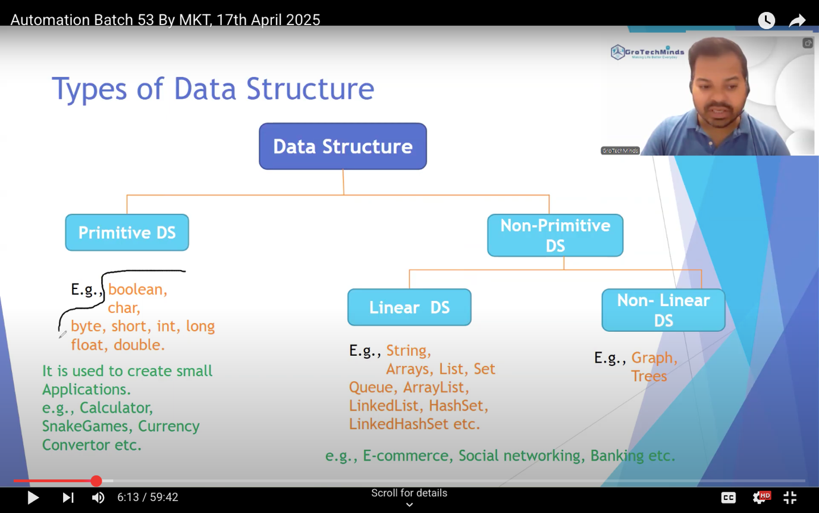

Why linear DS:
Whoever having ability to store the data that’s called as Linear DS

Like classes & Interface

Non-Linear DS:
Advance Java

Array | ArrayList
- Fixed size | - Dynamic size
- Can hold primitive & object | - Can store only object
- Int[] var=new Int[10]; | ArrayList[] List=New ArrayList();
- Allocated at Compile time | - Allocated at Run time
- No built in Iterator | - Iterator & ListIterator

Array | Collection
Array can store Primitive & Non Primitive type | Collection can store only Non Primitive
Can store Homogeneous value | Can Store Home & hetrogeneuos value
Fixed Size | We can increase (Dynamic size)

 | ArrayList | LinkedList
1. | This class uses a dynamic array to store the elements in it. With the introduction of generics, this class supports the storage of all types of objects. | This class uses a doubly linked list to store the elements in it. Similar to the ArrayList, this class also supports the storage of all types of objects.
2. | Manipulating ArrayList takes more time due to the internal implementation. Whenever we remove an element, internally, the array is traversed and the memory bits are shifted. | Manipulating LinkedList takes less time compared to ArrayList because, in a doubly-linked list, there is no concept of shifting the memory bits. The list is traversed and the reference link is changed.
3. | Inefficient memory utilization. | Good memory utilization.
4. | It can be one, two or multi-dimensional. | It can either be single, double or circular LinkedList.
5. | Insertion operation is slow. | Insertion operation is fast.
6. | This class implements a List interface. Therefore, this acts as a list. | This class implements both the List interface and the Deque interface. Therefore, it can act as a list and a deque.
7. | This class works better when the application demands storing the data and accessing it. | This class works better when the application demands manipulation of the stored data.
8. | Data access and storage is very efficient as it stores the elements according to the indexes. | Data access and storage is slow in LinkedList.
9. | Deletion operation is not very efficient. | Deletion operation is very efficient.
10. | It is used to store only similar types of data. | It is used to store any types of data.
11. | Less memory is used. | More memory is used.
12. | This is known as static memory allocation. | This is known as dynamic memory allocation.

Growth strategy

Map
Advance Java concept

- Key & Value

Map (Interface) methods:

Example

- Map m1=New HashMap();

M1.put(2224996 , “Keerthi”);
M2.put(xxxxxxx , “vasan”) ;

EMPID is unique

Value(Keerthi). ---Dynamic ,Duplicate

- PutAll
Map m2=New Hashmap();

M2.putall(m1); //this like collection addall from collection

- IsEmpty()
- putIfabsent()
- containsKey()
- ContainsValue()
- Replace()
- Get(object)
- Keyset() ------ return type set<String>
- Values -------return type Collection<Integer>
- Entryset()--------return type set<entry<string,Integer>>

2 methods of iterator
1)hasNext
2)Next

Map<String, Character> mp= new Hashmap();

1)Return type of Map is Set<Object>
2)Return type of Value in map is collection <Object>

List | Set | Map
Java.util.list | Java.util.set | Java.util.map
Allow to store duplicate value | Doesn’t allow duplicate value | Map store in the form Key-Value , it doesn’t allow to store duplicate value ,but allows duplicate value in Java
Maintain Insertion order | Doesn’t maintain Insertion Order | Most of the map classes doesn’t maintain insertion order
Allow many null values | Allow only one Null value | HashMap—Allow one null key and many null values  TreeMap---doesn’t allow nullkey & many null values  LinkedHashMap--- Allow one null key and many null values
List implementation classes are ArrayList,LinkedList | HashSet,LinkedHashSet,TreeSet | HashMap,HashTable,TreeMap,WeakHashMap & LinkedHashMap
Index | Unique | Key-Value
Iterator & ListIterator | Iterator | Only methods to do iterations  Keyset(),values() & entryset()

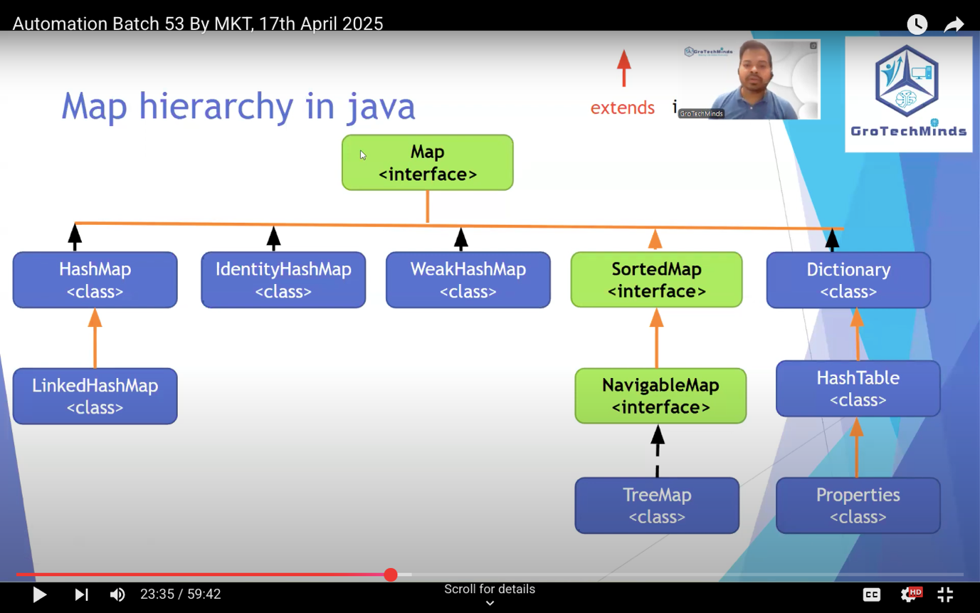

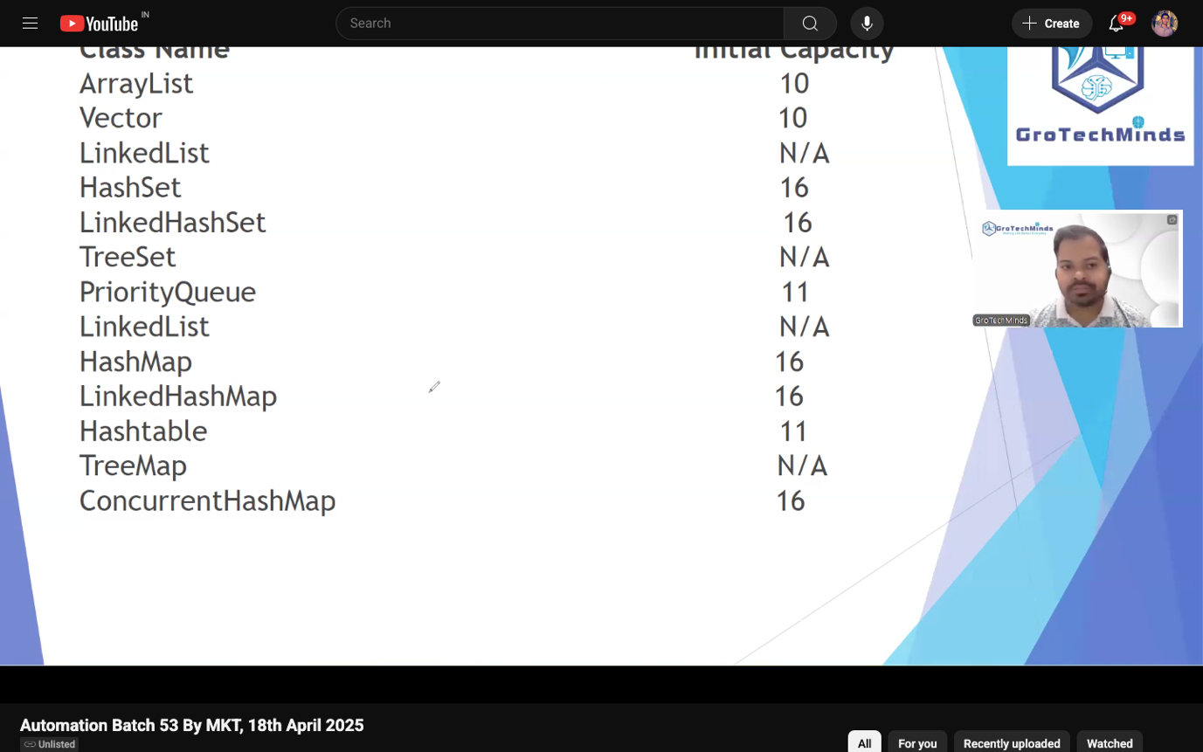

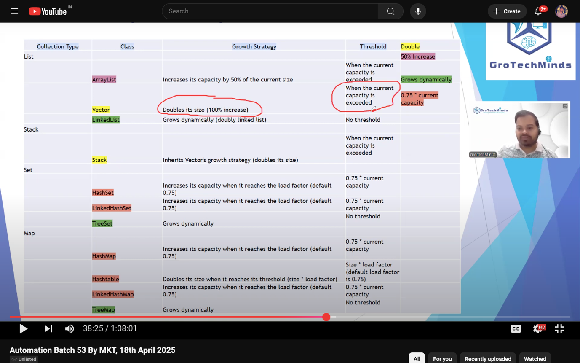

Sort: (Collections)

 | List(I) |  |  | Queue(I) | Set(I)
 | ArrayList(C)  ArrayList a1=new ArrayList();  a1.add | Vector(C) | LinkedList(C) | PriorityQueue(C) | TreeSet(C)  TreeSet t1=new TreeSet(); | HashSet(C) | LinkedHashSet(C)
Index | TRUE | TRUE | TRUE | FALSE | FALSE | FALSE | TRUE
Dynamic | TRUE | TRUE | TRUE | TRUE | TRUE | TRUE | TRUE
Hetrogenous | TRUE | TRUE | TRUE | FALSE | FALSE | TRUE | TRUE
Null | TRUE | TRUE | TRUE | FALSE | FALSE | Only one | Only One
Duplicate | TRUE | TRUE | TRUE | TRUE | FALSE | FALSE | FALSE
Sort | TRUE | TRUE | TRUE | FALSE | TRUE | FALSE | FALSE
Iterator | TRUE | TRUE | TRUE | TRUE | TRUE | TRUE | TRUE
ListIterator | TRUE | TRUE | TRUE | FALSE | FALSE | FALSE | FALSE
Enumeration | FALSE | TRUE | FALSE | FALSE | FALSE | FALSE | FALSE

Collection | Collections
It is interface | It is class
Collection got many Interfaces & classes | Lot of Methods

Most Import:

1)Collection & Collections
2)List vs Set Vs Map
3)List vs Set
4) Iterator vs ListIterator

Exception Handling

Throw keyword :

Can be use to throw an exception.
Syntax: throw new EXceptionName(); or throw new EXceptionName("Message");

- All the excpetion is basically a classes in Java
- Throws keyword is not mandatory but it is recommended to use in the program

throw | throws
we can throw an exception | we can declare an exception
single throw can throw only singel exception | single throws can declare as many as exceptions
throw keyword must be written inside the method | throws keyword must be written together with the method name
throw keyword cannot be used to handle checked exceptions | throws keyword can be use to handle checked exceptions

Exception Handlling:

Exception Handling
1. Exception hanlding in java can be done using try, catch and finally block.
2. Whichver line is giving exception must be in try block and it must be handled under catch block
3. One try can have one catch block or any number of catch block.
4. Writing try and catch in the code oesnt gurantee that exception will come , becase exception may or may not come.
5. if exception comes then catch block will execute.
6. If exception does not come then try block will execute
Syntax of try catch:
try
{
//this line was giving exception
}
catch(exceptionnname variable)
{
}
7. Syntex of finally block
try
{
//this line was giving exception
}
catch(exceptionnname variable)
{
}
finally
{
}

Partner :

Try and Catch

Final | Finally
1. Final Keyword can be used with a variable,method and class | Finally keyword/block can be use in the case of exception handling after the try and catch block
2. Any varibale is final that means you cant chnage its value | finally block should be written only after try and catch
3. Any method is final that means you can't override it | finally block will dedinately execute irrespective of try or which catch.
4. Any class is final which means we can't inherit it | Since After writing try and catch block we will not know in real time if try is executing or catch is executing , what we are sure ia finally block will always execute

Below mentioned are classes :

- Sleep > static method

- URL class can findout link is valid or not Valid. (URL i1= new URL();)

- FileInputStream class to find the where exactly sheet is present.

Thread.sleep > Interrupted Exception
FileInputStream
URL

Type of exception in Java:
1. Checked Exceptions
2. Uncheked Exceptions

Checked Exception | . Unchecked Exceptions
- Compile time | - Run time
Example : FileNotFoundException,  InterruptedException,  ClassNotFoundException,  SQLException | Ex  1)Arthematic Exception  2)NullPointerException  3)ArrayIndexOutOfBoundException

- Every exception in java is class
- Checked Exception inherit the Exception(c ) -- >Throwable( C ) ---- >Serilalizable(I )

Polymorphism in Java
An object showing different behaviour at different stages of its life cycle is called as Polymorphism.
polymorphism means same action in diffrent ways

Example:

One method name login , different argument (Method Overloading)

login | USERID
login | MOBILENO
login | EMAILID

Method Overloading | Methd Overriding
Dupicates method | Dupicates method
types of poly:
a) Compile Time Polymorphism:An object showing different behaviour at different stages of its life cycle at the compile time based on the arguments passed is called as CTP
CTP can be achived using Method Overlaoding.
b) Run Time Polymorphism:An object showing different behaviour at different stages of its life cycle during the run time based on the object created is called as Run Time Polymorpshim.
RTP can be achived using Method Overridng

This keyword: refer current class method,instance variable,construcotr

This keyword:

- We can’t use this keyword in Static method
- This keyword use to assign local variable to Global Variable
- this kwyrod shoudl be used only in the non static context
- this keyword can be the 1st line or secondline inside the non static method

this & super keyword

- Both should be used in Non static method & not mandatory in first/second line

This () & super() calling statement
- Both should be used in constructor & should be first line In constructor
- Super calling statement used to call the parent class constructor from Child class Constructor

- This calling statement used to call the One constructor from another constructor within the same class

- Super keyword should be used in the method overriding to call the parent class implementation together with child class implementation

- This keyword can be used in java to assign the value of local variable to Global variable

Return keyword

Encapsulation in Java
Protecting the data member of the class with access specifier private and giving the access indirectly with the help of getter and setter is called as Encapsulations.
The most sensitive information in the given application can be mde as private to avoid the direct access within the team members.
Ex: private int otp;
private String password;
private String username;
Getter method is use to get the value and Setter method is used to set the value.
The syntax of both getter and setters are:
public void getVariable()
{
}
public void setVariable()
{
}
The access specier of both the methods[getter and setters] will be public in nature.

----------------------------------------------------------------------------------------------------------------

Typecasting:

Converting one type to another type is called as type casting.
Type Casting are of 2 types:
a) primitive Type casting
b) Class type casting
Primitive Type casting: Concerting one datattype into another datatype .
2 types:

> a) Narrowing: COnverting bigger datypes to smaller datatypes Can be done in 1 way and that is explixitely: double b1=3.14; int b2=(int) b1;

> b) Widning:Converting smaller datatypes tp bigger datatypes. Can eb done in 2 ways:

a) Inplicit: int a=100; double d1= a;
fb) Explicit: int a=100; double d1=(double) a;

Widening

Byte > short > int > long > float > double

Narrowing

Class Type casting:
Concerting one class into another class .
2 types:
a) Upcasting: Converting child class object to super class type .
Can be done in 2 ways:
a) Implicitely: Parent p1=new Child();
b) Explicitely: Parent p1=(Parent)new Child();

Note : Downcasting is only possible once upcasting is done

b) DownCasting:Converting super class type into child class object.
Downcasting can be done only explicitely:
Explicitely: Child c1=(Child)p1;

Upcasting is very Important:

Date Class
Current Time | Log a message  Take a screenshot
Future Time
Paste Time

Math.randon() > take the screenshot

Server time >. Epoch converter

------------------------------------------------------------------------------------------------
Github | Code repository Tool
Create an Account | Github
Install a Software,Tool | Gitbash

www.github.com/username

- Github is a remote repository & our laptop is local repository
- Create a repository in remote (where we can keep the code)
- Initilize the repository in local git init ---- >//command to initlize in Git blash
- Clone the remote the rep into local repo git clone “remote rep url”

- ls ---- if you Ls , it will file names present in your folder

- cd “folder name”/

- git status --- it will show which are all files not been pushed to github in red colour

- git add “type file name first letter & press tab button”- > it will add files into github

- git add . - it will add all files

- git commit -m “ whatever typing here ,it will visible in github acc “ confirming

- it will ask for authentication (first time)

- git push - -all (repo url paste)

- after push in Github > under main branch file/code will be available

- Start adding files
- Commit the files
- Push the files (sending)
- https://github.com/keerthivasan59/naukri.git

git init | Initilize the repository
git clone RepositoryURL.git | To Clone the remote repo with local repo
Git status | To check the files which are not added still
Git add FileName | To add the single file
Git add . | To add multiple file
git commit -m "commit message" | commit
git push --all RepositoryURL.git
create a branch in the repo

Git pull RepositoryURL.git | taking code from remote to local
git fetch | Will give u the list of branch of that we have in the given repo
git checkout branch name | i can move the control from one branch to another

Git checkout ---for switch

What all concepts will be useful for Automation Testing:
List vs Set
Interfaces
ABstarct methods
non static method
Polymorphism
class
Object

Will be done in Selenium:
What is the purpose of static method?
What is the purpose of non static method?
What is the purpose of constructor method?
2 Dimensional Array
JVM Memory

Browsers | Chrome
 | Mozilla
 | Edge
 | Safari
 | OM
 | IE
 | Edge
OS | WIndows
 | MACOS
 | Linux
Selenium | Languages
 | Java
 | Python
 | Ruby
 | JS
 | .net/c#
Selenium |  | All the web based application
Selenium we can also do Cross browser and Parallel Testing
Drawback
1. Cannot automate mobile based app and stand alone app[No internet]
2. Cannot Automate
OTP,Captcha, Prove that you are human?,scanner ,bar codes,image etc
3. Selenium does not have its own reporting Tool(It need TestNG)
test case reporting tool
4. In Selenium we can never run multiple test cases together(It need TestNG)

Selenium | Tool | Jar
project |  | Java
 |  | Maven project

Configure the Selenium in our java project
Discuss Some classes in Selenium
How to launch different browsers in selenium
How to close browser
fetch title of any page in web based application
Launch Any URL
How to maximise and minimise the browser

- When you create an object of below
ChromeDriver driver=new ChromeDriver();

- Whenever object creation happens , it will invoke the constructor so that chrome will launch (constructor will invoke an empty browser)

- driver.get(“String url”) get is non static method

- driver.close(); it will close the parent browser/ window/tab, it will close that browser/window/tab that has the control

- driver.quit(); it will close all the browser/window or tabs

- driver.gettitle(); -> it will give you title of the page.

- driver.findElement(); find element for finding single single element

- driver.findElements(); find Elements for finding multiple elements all together.

- driver.getwindowhandle(); -> it will give you id of your parent browser or it will give you id of that particular window where u have control

- return type above is alpha numeric value (String)

- driver.getwindowhandles(); -> it will give browser id of parent and child windows
- return type above is alpha numeric value set <String>

Syntax:
Set<String > allwindows =driver.getWindowHandles();
Iterator i1=allwindows.iterator();
String parentId=(String)i1.next();
String childId = (String)i1.next();

FindElement | Locate | Actions
driver.findElement  driver.findelements | Locators in Selenium
 | id | clicking
 | name | typing
 | tagname | doubleclick
 | classname | rightclick
 | linktext | hoverover
 | partial linktext | drag and drop
 | xpath
 | CSS Selector

Default tag name for any link is <a ---- Link Text

Entire Keyboard functionality will be available under keys
eb1.sendKeys(Keys.CONTROL+"a");
eb1.sendkeys(Keys.Back_SPACE);

Xpath
1. Absolute X path |  | Traversing from parent tagname to immediate child tagname with the help of single forward slash.  Ex: /parent/child
2. Relative X path |  | Traversing any tagname directly with the help of double forward slash.  Ex: //child
how to write Absolute X path?
how to write RElative X path?

Next may7th class

- Syntax of writing xpath
//TagName[@AN='AV']

- How to write the Xpath for the text message
//TagName[.=’Textvalue’]
Or
//Tagname[text()=’TextValue’]
- //tagname[contains(@attribute, ‘partial_value’)]

- we can have both combination of Relative & absolute X apth
- 3 Abstract method of WebELement Interface
isenabled,isdisplayed and isSelected

- isEnabled------if element is enable or not

- IsDisplayed--- if element is presence or not

- IsSelected -----if element is selected or not

- Above all of things are Boolean

- How to work with dropdowns
- Most of the dropdown will be having select as tagname and in order to handle them selenium provides us Select Class

- Syntax:

- Select s1=new Select(WebElement e1); ex: select s1=new select(e1);

- S1.selectByValue(String input); ex: s1.selectByValue(“Search-alias=stribooks”);

- S1.selectByIndex(int i); ex : s1.selectByIndex(1);

- S1.selectByVisibletext(); ex: s1.selectByVisible(“car & Motorbike”);

- e1 is that components on which we wish to perform dropdown

- Handle without Select classes for dropdown

- Webelement eb=driver.findElementByXpath(“ “);

>eb.click();
>eb.sendkeys(Keys.Arrow_Down);
Note: if u want to select four arrow down click > you have to enter four times below example to select 3rd value

>e1.sendkey(Keys.Arrow_Down);
> e1.sendkey(Keys.Arrow_Down);
>e1.sendkeys(Keys.Arrow_Down);
>e1.sendkeys(Keys.Enter);

- How to select Multiple dropdown values

1)How to Handle hoverover
Syntax: Actions a1=new Actions(driver); - >if u through the parameter as driver then only it will invoke the constructor.
>a1.movetoelement(e1).perform(); --Non static method(movetoelement)
->e1 -that component on which you wish to perform hoverover

----------------------

2)How to Handle drag and drop
3)How to Handle double click
4)How to Handle Right click

Above all are possible in Action Class

2) How to Handle drag and drop

Syntax:
Actions a1=new Actions(driver);
a1.draganddrop(e1,e2).perform();

e1- >that component which u want to drap
e2 that component where u wish to drop

- How to Handle double click

Actions a1=new Actions(driver);
a1.doubleclick(e1).perform();

e1- > that component where u wish to do double click

example:
1)to select the text
2)to open the folders in google drive or any application where u can see folders

4)How to handle right click

Actions a1=new Actions(driver);
a1.contextclick(e1).perform();

e1- that component where u wish to do right click

In how many ways we can click on a link?
W1.click();
Doubleclick();
Keys.Enter();

Navigation methods
1)driver.navigate().back();
2)driver.navigate().forward();
3)driver.navigate().refresh();

> to eliminate captcha
> if u have filled the form but now u feel u have to submit with Some other details.

4)driver.navigate().to(“url”);

------------------------------------------------------------------------------------------------
- How to count number of links in the page of a given website

Example :
List<WebElement> links=driver.findElements(By.tagname(“a”);

Int count =link.size(); --- >size method present in List concept
S.o.p(count);

- How to print all the links [url] in the page of a given website

Example:

List<WebElement> links=driver.findElements(By.tagname(“a”);

For(int i=0;i<link.size;i++)
{

Webelement link1=link.get(i);
String url=link1.getDomAttribute(“href”);
S.o.p(url);

How to print all the linktext in the page of a given website
public class GoogleAllLink2
{
public static void main(String[] args)
{
ChromeDriver driver=new ChromeDriver();
driver.get("https://www.google.com");
List<WebElement> link= driver.findElements(By.tagName("a"));
for(int i=0;i<link.size();i++)
{
WebElement link1= link.get(i);
String url= link1.getDomAttribute("href");
String text= link1.getText();
System.out.println(url);
System.out.println(text);
}

}
}

Syntax: scroll down

Step 1: WebElement wb1=driver.findByElement(By.xpath( “ “ ));
Step 2: Point p1= wb1.getLocation(); //return type is point
Step 3: Int x=p1.getX();
Step 4 : int y=p1.getY();
Step 5: JavascriptExecutor js=driver; //JavascriptExecutor is Interface
Step 6: js.executeScript(“Window.scrollBy(0, “+y+”));

Syntax : screenshot’s

Step 1: TakesScreenshot ts=driver;
Step 2: File Source= ts.getScreenshotAs(OutputType.File)
Step 3: File Destination=new file ( “ “);
Step 4: FileHandler.copy(Source,Destination)

How to take unique Screenshot’s
3 ways
1)Math.random
Example: File Destination=new File (“E:\\project\\ab23\\keerthi”+Math.random()+”.png”);
2) Date class
3) By class name

How to scroll down or up

public class AmazonScrolldown2
{
public static void main(String[] args) throws InterruptedException
{

EdgeDriver driver=new EdgeDriver();
driver.get("https://www.amazon.in");
WebElement e1= driver.findElement(By.linkText("About Amazon"));

JavascriptExecutor js=driver;//upcasting from driver to JavascriptExecutor(I)

js.executeScript("window.scrollBy(0,500)"); ------------------ imp
Thread.sleep(2000);
js.executeScript("window.scrollBy(0,-500)");

}
}

How to take screenshots
1)upcasting driver to TakesScreenshot(I)
2) Use its abstract method called getscreenshotAs to take a screenshot [Source]
3) Create the object of the file class to give the location where exactly we want to store the screenshot [Destination]
4) use Filehandler class to copy the file from source to destination

How to take unique screenshots

First way:
a)Math.random

ex: File destination=new File(“E:\\MKTproject\\Ab54\\screenshot\\keerthi”+Math.random()+”.png”);

Second Way:
File(“E:\\MKTproject\\Ab54\\screenshot\\keerthi”+new LoginToAmazon().getclass()+”.png”);

1)get class is one of the method of object class
2)here Keerthi is not mandatory
3)Math.random is drawback

Third Way:

Screenshot topic till 22:19 mins

b)Date class
c) class name
How to hanlde pop ups
a) Java Script popups
b) Parent child window based pop ups
c) File upload pop ups
d) Application based pop ups
e) Browser based pop ups

- How to handle Java script pop ups
>Any javascript popup will never be inspectable(right click won’t click)
> Most of the JS pop ups gives max 2options or 1 option.
Example:
- Are you Sure?
Yes No

- Want to upload resume?
Yes No

- Are you over 18?
Yes No
- Switch on Your Camera
Yes No

- Share my live location?
Yes No

All the java script pop ups are mandatory pop ups to handle else it will give it will give you unhandleAlert Exception

Best way to handle JS pop ups is below

1)driver.switchTo().alert().accept();--------Yes. (if your answer is Yes)
2)driver.switchTo().alert().dismiss();-------No. (if your answer is no)

- Parent child window based pop ups

How to maximize & minimize browser

- driver.manage().windows().maximize();
- driver.manage().window().minimize();

- driver.close();--- will close the parent window

- driver.getWindowHandles()---fetch id from parent & child window

Example:
Set<String> ids= driver.getWindowHandles();
Iterator<String> i1=ids.iterator();
String parented=i1.next();
String child id= i1.next();

Syntax: (to switch from parent to child window)
Driver.switchTo().Window(childId);

14-May-2025
c) File upload pop ups

Example:
WebElement e1=driver.findElement(By.name(“profile-upload”));
- e1.sendkeys(“**”);--- > in double quotes you have to give path of the file

d) Browser Based Pop ups

e)- > Application based Pop ups

CSS Selector:

- With ID #IDVALUE
- With Classname .classname
- With tagname and classname Tagname.Classname
- Tagname,Attribute name & Attribute value Tagname[AN=’AV’]
- Tagname,classname,AN & AV TN.CN[AN=’AV’]
- Caret Symbol(^)

Tagname[AN^=’Partial AV’]

https://grotechminds.com/explicit-wait-and-its-methods-in-selenium-webdriver/

maximise and minimize the browser
CSS Selector
how to find out the colour of any component
how to handle drag and drop
how to handle double click
how to handle right click
how to write xpat for the text message:
//Tagname[.='TextValue']
or
//Tagname[text()='TextValue']
isdisplayed | If eleement is presense or not
isSelected | If element is selected or not

How to handle Auto suggestion:

- Identify the xpath for all autosuggestion values

Example:

List<Webelements> list =driver.findElements(By.Xpath(“ “); // return is List <WebElements>

Int count= list.size(); //size is the method of list
System.out.println(count);
list.get(0).click(); // get is the method of list ,

15-May-2025

Some Autosuggestion will disappear automatically

- Once u inspect the page , right side inspect page there u can click pause icon & stop the auto suggestion

Imp scenario:
- Open the google website , search any product after that select 1 or 2 or 3 products

Webdriver driver=new Chromedriver();
driver.get(“ url” );
List <Webelement> wb1=driver.findElements(By.Xpath(“” ));

Wb1.get(0).click(); // get(0) indexing value with list method

Browser Based pop up

- Login into facebook with right credential then you will be getting browser based pop
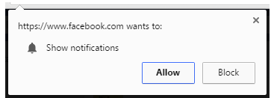

To handle above pop up below script
Chromeoptions cop=new ChromeOptions();

Cop.addarguments(“—Disable notifications”);

Chromedriver driver=new Chromdriver(cop);

Robot Class: DDT: (Data driven testing)

- Whenever you need the help of Mouse & Keyboard

Example:
1)After doing right click selecting its 3rd option or 2nd Option need keyboard
2) After copying something, while pasting it you can do right click and paste it using paste options available which can be selected using keyboard.

Program:
Robot rb1 =new Robot();
rb1.keyPress(KeyEvent.VK_Down);

//keypress- non static method & KeyEvent ---- > Class has entire virtual keyboard keys

16-May-2025

Syntax:
- e1.sendkeys(Keys.control+ “a”); // select all thing
- e1.sendkeys(Keys.control+ “c”); // copy the value

DDT – Data Driven Testing

Fetching the data in the code from the excel sheet

1)Username
2)password
3)Card no
4) CVV no
5)Expiry date

Download the jar Apache poi
Add the excel sheet in the project

Steps: (Non Technical way )
1.provide the location of excel sheet to let java know where exactly from it has to fetch the value.
Example: FileInputStream
2.Open the sheet
Example: Workbookfactory.create
3.Mention the sheet name where your data is
Example: getsheet
4. Mention the row where your data is
Example: getrow
5.Mention the cell where your data is
Example : getcell
6.fetch the value from the method called getStringCellValue()

Example program:
FileInputStream f1 = new FileInputStream( “ excel path “) ;

Workbook wb=WorkbookFactory.create(f1);
Sheet s1=wb.getSheet(“Login”); //sheet name
Row r1= s1.getRow(0);
Cell c1= r1.getCell(0);
String value=c1.getStringCellValue();
System.out.println(value);

Setup
1)Eclipse
2)Selenium jar
3) TestNg
4)Apache poi

When will you get expections:

1.When you fetch the value from an empty cell
2. if the location of excel sheet is wrong
3.When you will fetch the numeric value using getstringcellvalue

Exception comes different way below
- if mentioned file path wrong means -> FileNotException
- Fetching the value from empty cell --- >NullPointerException

String pwd= NumberToTextConverter.toText(“ …….”); // convert numberic to String

-------------------------------------------------------------------------------------------------------------------------
19-May-2025

- When you want to test a login with 5 set of values?
- Google search with 20 set of values?

Yes, DDT + TestNG @DataProvider

2 Dimension Array

Int array[] =new int[size];
Int array[][]=new int [row size][Column size]; d

TestNG:
- It is a framework and also a tool can be integerated with selenium for mainly below reasons:
- To run multiple test cases together.
- To generate the report

Drawback of selenium:
It does not have its own capability to generate report so it depend of 3rd party tool like TestNG.

Note:
- Download the TestNG and Configure to your project. [Java project]
- Add it’s library.
- As long as you are dealing with TestNg always use @ Test instead of main method

Syntax of TestNG class:

Class className
{
@Test
Public void methodname()
{

}
}

Imp point:
- @Test -> indicates one test case
- If 2 @Test present indicates two test case

How to run single test files in TestNg?
How to generate TestNG.xml file?
How to add extra classnames to testNg.xml file?
How to see emailable report?
How we can modify the suite name and test name in testNg.xml file?

How many different Annottations that we have in TestNg?

Total 9 annonation

- @BeforeSuite [Optional]
- @BeforeTest [Optional]
- @BeforeClass [Optional]
- @BeforeMethod [Optional]
- @Test --------Mandatory (Without test annotation it will not run)
- @AfterMethod [Optional]
- @AfterClass [Optional]
- @AfterTest [Optional]
- @AfterSuite [Optional]

20-May-2025

Parameter of @test
How to run the programs parelly and cross browser testing
How to skip a test case

Important Note:

Before Method & After Method always gets execute with each & every test.

Priority:

@Test (Priority=3)
Public void logout()
{
}
@Test(priority=2)
Public void login()
{
}
@Test(Priority=1)
Public void registration()
{
}

Can it be 0? Yes
Can it be negative? Yes
Can 2 test have same priority? Yes

What is the default priority of any @Test?

How to run same test cases Multiple Times? -> invocationCount
Example:
- @Test(invocationCount=5)
Public void registration()
{
S.o.p
}
Can we have priority and Invocation together?
1)@Test(invocationCount=5,priority=-1)
Public void registration()
{
S.o.p
}

How to enable and Disable any @Test? ->

Example:
@Test(enabled=false)
Public void login(){
S.O.P();
}

What is the default invocation Count of any test?

What is timeout parameter of TestNG?

API automation

@test(timeout=1000) /// 1 second mentioned here
Public void login()
{
ChromeDriver driver=new ChromeDriver(); // will take atleast 4 to 5 sec to launch the browser

System.out.println(“Test case 1-Login”);
}

Note:ThreadTimeoutException (Not important)
--------------------------------------------------------------------------------------------------------------------------

How to run the program parallel & cross browser testing

- Refer 20-May-2025 video from 45:00 after comparability testing means doing testing in different browser one by one

 | Console | Report
System.out.println(“ “); | True | False
Reporter.log(“ “); | False | True

Reporter is class in the testNG --in emailable report

<?xml version="1.0" encoding="UTF-8"?>
<!DOCTYPE suite SYSTEM "https://testng.org/testng-1.0.dtd">
<suite name="sample testing" parallel="tests">
<test thread-count="5" name="Test">
<parameter name="browserlan" value="chrome"></parameter>
<classes>
<class name="testNGprogram.testcase1"/>
<class name="testNGprogram.testcase2"/>
<class name="testNGprogram.testcase3"/>
</classes>
</test> <!-- Test -->
</suite> <!-- Suite -->

Assertion in TestNG

HardAssert | Assert Class  Have only static methods  This topic should be used only in @Test methods and in main method | Assertion class  Can be used in @Test also and we can use this in main method also
SoftAssert | SoftAssert Class  Can be used in @Test also we can use this in main method also  SoftAssert class has only non static methods in it
Methods of Assert , Assertion and SoftAssert are same

HardAssert | Comparison of Expected beh vs Actual Behavior  And in case they don’t match it will terminate the program
SoftAssert | Comparison of Expected beh vs Actual Behavior  And in case they don’t match it will not terminate the program it will just log the message in console  SoftAssert class  Can be used in @Test also and we can see this in main method also  SoftAssert class has only non static methods in it.  After using its all method please use asserall() at last to note down the list of assertion error

Assert.assertTrue(false);
Assert.assertTrue(True);
Assert.assertFalse(false);
Assert.assertFalse(True);
23-May-2035

Assert.assertEquals(false,false);
Syntax:
- Assert.assertEquals(boolean,boolean);

- Assert.assertEquals(boolean[] , Boolean[]);

- Assert.assertEquals(Boolean, Boolean);

- Assert.assertEquals(boolean, Boolean);

- Assert.assertEquals(Collection, Collection);

- Assert.assertEquals(Set, Set);

- Assert.assertEquals(Map, Map);

- Assert.assetEquals(Object,Object);

- Assert.assertEquals(Object[], object[]);

10)Asser.assertNotEquals(Set, set);

- Assert.assertNotEquals(Collection,Collection);

- Assert.assertNotEquals(Map,Map);

- Assert.assertNotEquals(Object , Object);

Some many methods are there

Note:
Expected behaviour should be hand written
Actual Behaviour should come from Predefined methods

Q1:
Launch google and verify the test case is pass
@Test
public void test1() {
ChromeDriver driver=new ChromeDriver();
driver.get("https://www.google.com/");
driver.manage().window().maximize();
Assert.assertEquals(driver.getTitle(), "Google");
}

Q2:Launch amazon search the product and verify if the test is pass.

@Test
public void test2() {
ChromeDriver driver=new ChromeDriver();
driver.get("https://www.amazon.in/");
WebElement wb1 = driver.findElement(By.xpath("//input[@id='twotabsearchtextbox']"));
wb1.sendKeys("shoe");
wb1.sendKeys(Keys.ENTER);
List<WebElement> wb11=driver.findElements(By.xpath("//a[@class='a-link-normal s-no-outline']"));
Assert.assertEquals(wb11.size()>50,true);
driver.quit();
}

Soft Asserion syntax:

SoftAssert s1=new SoftAssert();

S1.assertEquals(driver.getTitle(), “ “); // line 10

S1.assertEquals( “ “ , “”); // line 80
S1.assertAll(); ---------------Mandatory

Imp point:

- Create object once whenever we want soft assertion ,we can make use of reference variable in the code ,but one thing we should mention at last ( s1.assertAll();)

Assert Methods:

- Assert.assertEquals( …);
- Assert.assertnotEquals(….);

Syntax:

LinkedIn content Below
✅ Q1: What is Data Abstraction? How is it used in Selenium Framework?
Answer:
Data Abstraction means hiding internal details and showing only the required functionality.
In Java, we achieve this using interfaces and abstract classes.
📌 Selenium Example:
WebDriver driver = new ChromeDriver();
WebDriver is an interface.
ChromeDriver is a class that implements it.
📌 In Framework (POM):
In Page Object Model, we hide locators and actions inside page classes. Tests use only public methods without knowing how they work inside.
✅ Q2: What is Encapsulation? How is it applied in Automation Framework?
Answer:
Encapsulation means keeping variables private and accessing them via public methods.
📌 Example in POM:
@FindBy(id = "loginBtn")
private WebElement loginButton;
public void clickLogin() {
loginButton.click();
}
Locators are private
Accessed via public methods
Keeps data safe and code clean
✅ Q3: What is Inheritance? How is it used in Selenium Framework?
Answer:
Inheritance allows one class to reuse properties and methods from another class.
📌 Example:
public class BaseTest {
public void setup() {
// browser setup
}
}
public class LoginTest extends BaseTest {
public void testLogin() {
setup(); // inherited from BaseTest
}
}
We keep common logic in Base Class
Other classes extend it to reuse code
✅ Q4: What is Polymorphism? How do we use it in Automation?
Answer:
Polymorphism means performing the same action in different ways.
✅ Method Overloading:
Same method name, different parameters.
assertTrue(condition);
assertTrue(condition, "Custom message");
✅ Method Overriding:
Subclass provides a new version of a method from its parent.
📌 Example:
Custom WebDriver class overriding findElement() for logging.
✅ Q4: What is the difference between Interface and Abstract Class?
Answer:
Interface provides full abstraction with only abstract methods (by default), while an abstract class can have both abstract and concrete methods. An interface supports multiple inheritance; an abstract class does not.

1)WAP to find the Second largest number in the given array
1) package Grotechpack;
public class Main {
static int Program1(int[] a)
{
int max1=0,max2=0;
if(a[0]>a[1])
{
max1=a[0];
max2=a[1];
}
else
{
max2=a[0];
max1=a[1];
}
for(int i=2;i<a.length;i++)
{
if(a[i]>max1)
{
max2=max1;
max1=a[i];
}
else if(a[i]>max2)
{
max2=a[i];
}
}
return max2;
}
public static void main(String[] args)
{
int[] a={10,20,30,40,50,60};
System.out.println(Program1(a));
}
}

2)WAP to find the Second smallest number in the given array

https://youtu.be/3S_KuSb9HHE?si=TCt30OfC8xp-XCmP

package Grotechpack;
public class Main {
static int Program1(int[] a)
{
int max1=0,max2=0;
if(a[0]>a[1])
{
max1=a[0];
max2=a[1];
}
else
{
max2=a[0];
max1=a[1];
}
for(int i=2;i<a.length;i++)
{
if(a[i]<max1)
{
max2=max1;
max1=a[i];
}
else if(a[i]<max2)
{
max2=a[i];
}
}
return max1;
}
public static void main(String[] args)
{
int[] a={30,42,50,60,234,32,34};
System.out.println(Program1(a));
}
}

- Reverse a String & palindrome/Not Palindrome
- package Grotechpack;
- public class Main {
- public static void main(String[] args)
- {
- String str1="Keerthivasan";
- String str2="";
- for(int i=str1.length()-1;i>=0;i--)
- {
- str2=str2+str1.charAt(i);
- }
- System.out.println(str2);
- if(str1.equals(str2))
- {
- System.out.println("Palindrome");
- }
- else
- {
- System.out.println("Not palindrome");
- }
- }
- }

https://youtu.be/ZbnHSck-Clo?si=COQqSjLlU-Dr3fIZ

Reverse Each words from the sentence
package Grotechpack;
public class reverseEachwords {
public static void main(String[] args) {
// TODO Auto-generated method stub
String str="keerthi vasan kavitha shri"; //original string
String [] words=str.split(" "); // Splitting string into words
String reversestring="";
for(String w:words)
{
String reverseword="";
for(int i=w.length()-1;i>=0;i--)
{
reverseword=reverseword+w.charAt(i);
}
reversestring=reversestring+reverseword+ " ";
}
System.out.print(reversestring);
}
}

File upload handle:
https://youtu.be/VFiF3E-HFbc?si=LL5v1I_7xnHDFhGa

Data provider Annonations:

Testing the same test case with multiple set of values

Example:
Search on Amazon mobile,laptop,shoe,charger,Toys,indoor games,photo grames,mobile

Difficult concept :

Return type of data provider annotation is also Object class that’s too object of Two dimensional array.

Example program:

@Dataprovider(name=’data1’)
Public object[][] method(){

Object[][] data =new Object[8][1]; /// row first // column second
data[0][0]= “Mobile”;
data[1][0]= “Laptop”;
data[2][0]=”shoe”;
data[3][0]=”Charger”;
data[4][0]=”toys”;
data[5][0]=”indoor games”;
data[6][0]=”photo frames”
data[7][0]=”mobile back cover”
return data;
}

@Test(dataProvider=”data1”)

27-May-2025

2nd example for data provider concept

@DataProvider(name=’logindetails’)
Public Object[][] testdata()
{
Object [][] d1=new Object[5][2];

//1st row-right emailed as UN right PWD
D1[0][0]=” keerthi@gmail.com”;
D1[0][1]=”keerhi”;

//2nd row-right mobile number as UN and right pwd

D1[1][0]=”9750650605”
D1[1][1]=”wejrewf”;

//3rd row-right UN wrong password
D1[2][0]=dsfsef@gmail.com
D1[2][1]=”sdsfds”;

//4th row-Blank UN blank PWD
D1[3][0]=” “;
D1[3][1]= ” ”;

//5th row wrong UN wrong UN
D1[4][0]=sdsf@gmail.com;
D1[4][1]= “ “;
return d1;

@Test(dataprovider=” “)
Public static void multiplesetofValues(String un,String pwd)
{

ChromeDriver driver=new ChromeDriver();
Driver.get( “ “);
WebElement wb1=driver.findElement(By.Xpath( “ “));

Wb1.sendkeys(un);

WebElement wb2=driver.findElement(By.Xpath( “ “));

Wb2.sendkeys(pwd);

Example 3: How to integrate DDT concept @DataProvider

@DataProvider(name=’logindetails’)
Public Object[][] testdata()
{
Object [][] d1=new Object[5][2];

Step1: FileInputStream s1=new FileInputStream( “ location of the file”);
Step2: WorkbookFactory.create(s1);
Step3: un1 =w1.getSheet(login).getrow(0).getCell(0).getStringcellValue();
Step4 : pwd =w1.getSheet(login).getrow(0).getCell(0).getStringcellValue();

//
Step 5: un2 =w1.getSheet(login).getrow(0).getCell(0).getStringcellValue();
Step 6 : pwd2 =w1.getSheet(login).getrow(0).getCell(0).getStringcellValue();

//1st row-right emailed as UN right PWD
D1[0][0]=”un1”;
D1[0][1]=”pwd”;

//2nd row-right mobile number as UN and right pwd

D1[1][0]=”un2”
D1[1][1]=”pwd2”;

//3rd row-right UN wrong password
D1[2][0]=dsfsef@gmail.com
D1[2][1]=”sdsfds”;

//4th row-Blank UN blank PWD
D1[3][0]=” “;
D1[3][1]= ” ”;

//5th row wrong UN wrong UN
D1[4][0]=sdsf@gmail.com;
D1[4][1]= “ “;
return d1;

@Test(dataprovider=” “)
Public static void multiplesetofValues(String un,String pwd)
{

ChromeDriver driver=new ChromeDriver();
Driver.get( “ “);
WebElement wb1=driver.findElement(By.Xpath( “ “));

Wb1.sendkeys(un);

WebElement wb2=driver.findElement(By.Xpath( “ “));

Wb2.sendkeys(pwd);

Video- 27-May (part2)
How we get to know failed test cases

- Once we see failure in console
- Under test-Output folder > we can see testing-failed.xml

Note : crtl+shift+O--- shortcut way to import

28-May-2025
How to retry the failed test cases in testNG (
Aumation)
IRetryAnalyzer

- Create a class and implements IRetryAnalyzer()
- Override it’s un implemented methods
- Write your own logic to retry the test case
- Create a class to utilize the above logic
Example program:
package testNGprogram;
import org.testng.IRetryAnalyzer;
import org.testng.ITestResult;
public class RetryLogic implements IRetryAnalyzer{
{
int initialcount=0;
int retrycount=2;
}
@Override
public boolean retry(ITestResult result) {
// TODO Auto-generated method stub
if(initialcount<retrycount)
{
initialcount++;
return true;
}
return false;
}
}

Another program retry should be written in @Test annonations

@Test(retryanalyzer=RetryLogic.class)

// program lines

Imp point:

1)Retry most important when internet is slow
2) Test Environment is not stable
3)Always say interview > Retry atleast 2 times

What is TestNG Listerners?

TestNG Listerner is piece of code that will execute for every @Test activity

Types :

- ITestListener ----------- most Imp for Automation
- IReporter
- ISuiteListener
- IInvokedMethod
- IHookable
- IConfigurationListener
- IConfigurableListener
- IAnnotationTransformer
- IExecution
- IMethodInterceptor

ITestListener

- Create a class and implements ITestListener(I)
- Override it’s un implemented methods
- Write your own logic to retry the test case
- Create a class to utilize the above logic

Imp point:
- In order to get the @Override in program
- Right click >Source>Override/Implement Methods >Select all > Okay
- Always better to write @Test and @Listener in the same program

Example program:

Main program:

import org.openqa.selenium.By;
import org.openqa.selenium.chrome.ChromeDriver;
import org.testng.annotations.Listeners;
import org.testng.annotations.Test;
@Listeners(ListernerLogicForTestCases.class)
Public class TestcaseForListener

{

@Test
Public void method1()
{

///
Execting program

}

}

ListenerLogicForTestcases:

Package a…
Import org.testng.ITestListener;
Public class ListenerLogicForTestCases implements ITestListener
{

@Override
Public void onTestSuccess(ITestResults result){
//logic
ITestListener.super.onTestSuccess(result);
Reporter.log(“Test is pass-Listener”);

}

@override
Public void onTestFailure(ITestResult result){

//
Reporter.log(“Test is Fail-Listener”);
}

Takes screenshot syntax:

TakesScreenshot ts= driver;

File source = ts.getScreenshotAs(OutputType.FILE);
File destination =new File(“E:\\MKTProject\\SS ); folder path

29-May-2025

Imp question:
WAP to find out the brokens links in the given page of the website

Status code
Success  2xx | 200 ---okay  201 ---- ok created
Client side Error  4xx | 400 -- -Bad Request  401 --- Unauthorized  403 ----Forbidden /Prohibited  404 -----Not found
Server side Error  5xx | 500 --- ISE  503 ---- Service Unavailable  504 --- Gateway Timeout

In any application you can do only below things
CRUD
Create ----- Registration ,post on linkedin,Uploaded one photo on insta
Read --- Browsing internet ,Listeing to music,watching video
Update - ---- upload photo , upload video
Delete -------- Delete video ,Delete post on facebook

Example program:

Webdriver driver=new Webdriver();
Driver.get(“url”);

List<WebElement> link=driver.findElements(By.tagname(“a”));

For(int i=0;i<link.size();i++)
{
WebElement a1=link.get(i);
String url=a1.getDomAttribute(“href”));
S.O.P(url);
Verifythelink(url);
}
Static void verifythelink(String url)
{
URL u1=new URL(url);
HttpURLConnection c1=(HttpURLConnection) u1.openConnection();

If(c1.getResponseCode()==200)
{
S.o.p(“Link is valid “+c1.getResponseMessage());
}
Else
{
s.o.p(“Link is not valid”);
}

Runtimeexception can’t handle using throw keyword

Topic below all are JavascriptExecutor:
1)How to type on a component without using sendkeys
2)How to perform action on disabled component
3)How to perform action on those component which are under SHADOM DOM
4)How to handle IFRAM
5)How to scroll up & down

Anotherway to send the values to the fields:

First way:
WebElement emailbox=driver.findElement(By.Xpath(“ ,,,”);

driver.executeScript(“arguments[0].value=’Keerthi’”,emailbox);

Second way:
JavascriptExecutor js= driver; //JSE -Interface
Js.executeScript(“arguments[0].value=’Keerthi’”,emailbox);
30-May-2025

Page Object Model----- very Imp concept

- It is also called as Lazy Initilization technique
- POM is java design pattern using we will be able to locate every component just once and we will be able to utilize it any number of times

 | Imagine if UN Text field Xpath gets change tomorrow
Test case1 | UN Text field is used | Just Change one class and it will start reflecting in 10 test cases
Test case2 | UN Text field is used
Test case3 | UN Text field is used
Test case10 | UN Text field is used

maven-archtype-quickstart-----1.5

POM always need two package

- Source ---------- All the pages of the given website will be present in the form of class like HomePage.Java
- RegistrationPage.Java
- LoginPage.java
- WishListPage.java

- Test ---------All the test cases will be present

- Test folder Test case 1,Test case 2,Test case3

Imp point below

Example

HomePage.java ---- Each Source File should consist of 3 steps
- Locating each component with @FindBy
- Creating separate methods for each component to perform its action
- Initilizing the component inside the constructor using the pagefactory class

POM------------------------------------Maven Project
We need to install maven project Manually in eclipse

- Src/main/java -------- where we can keep all the source files
- Src/test/java -------- where we can keep all the test case files

Pom.xml--project Object Model

Pom.xml -only going to control entire project

Every organization following Maven Project

Maven project > POM.xml

Those are all called as dependencies
- Selenium jar
- Apache POI jar
- testNg lib

Step 1> Go to maven repo in browser >Selenium copy the dependency name > paste in POM.XML

Step 2> Go to maven repo in browser >testng copy the dependency name > paste in POM.XML

Step3> Right click on project name >Build path> Add libra>select testNG> Click on Finish

2/3-June-2025----done

4th June -----Done

5th June

Test case1 - -> Convert these test cases into testNG.xml file
Test case2
Test case3
Test case4
Test case5

>- > Integrate testNG.xml with pom.xml > Github> Jenkins > Schedule it

- we have run test cases in POM.XML > not in testing.xml
- if we want to run testcases via POM.XML means > we have to add SureFire plugin ( in pom.xml file)

Imp point:

- Jenkins doesn’t support testNG.xml . it only support POM.XML .we always run pom.xml

Report we can see under below

- Target>surefire-reports>emailable-report.html

Project:
- Project type ----- > Maven
- Framework ----- testNG
- Design pattern-- POM.xml
- Data-------------- Excel ------ Only 1 time -16th may video
- Retry test case- IRetryAnalyzer ----Only 1 time
- Screenshots---- ITestListeners -----Only 1 time
- Assestions------ SoftAssert/hard
- ------------------- testNG.xml
- Integrate with pom.xml and finally running the pom.xml
- Baseclass -------------------------------------Only 1 time
- Parallel and Cross browser

>Github
>Jenkins
>Synchronization
>Headless browsing

Synchronization

Thread.sleep(1000); ----------- Hardsleep

- What if my application is loaded with 1 sec
- What if my application is loaded with 9 sec

1)ImplicitWait
2)ExplicitWait
3)FluientWait

ImplicitWait:

Syntax:
- driver.manage().timeouts().implicitlyWait(Duration.ofSeconds(10));
Duration----class
ofSeconds- static method

- Once written it is going to be applicable throughout the code
- That’s the reason we should always write it only once on top of the program generally after launching the browser
- Even after 10 sec (Which is threshold time) if element is not found it will give you an exception called NoSuchElementException
- Polling period of IW>500msec or half second
- Since you have given the max time as 10 sec and let say your component is loaded within 1 sec, then we will end up saving 9 sec
- Drawback below
- IW is only application for 2 methods in Selenium one is FindElement and FindElements

6-june-2025

Explicit wait:

We have first create object

Syntax:

WebDriverWait wait=new WebDriverWait(driver, Duration.ofSeconds(10));

wait.until(ExpectedConditions.titleIs(“Google”));

Duration----class
ofSeconds- static method
10---
ExpectedConditions ----------class
Title is --------------it’s static method

- Once written it is only applicable to the next line
- Even after 10 sec (Which is threshold time) if the condition is not satisfying then we will get an exception called TimeoutException
- Polling period of IW>500msec or half second
- Since you have given the max time as 10 sec and let say your component is loaded within 1 sec, then we will end up saving 9 sec
- Drawback below
- EW is only application for ALL the methods in Selenium together with FE and FE’S

9-june-2025

WebDriverWait wait=new WebDriverWait(driver, Duration.ofSeconds(10));

wait.until(ExpectedConditions.titleContaints(“Online”));

Imp point : if above line is not working , then next line won’t execute

Methods for wait:
- Titleis
- Titlecontains
- UrlToBe()
- UrlContains()
- urlMatches()
- visibilityofElementLocated(By.id(“ “)); --------------Most famous
- alertIsPresent() ;
- elementToBeClickable
- visibilityofAllElementsLocatedBy

Drawbacks of Explicit wait:
- Polling is fixed
- We don’t have option to handle any expection in the case of Explicitwait

FluentWait:

This is advanced sync concept of explicit wait

FluentWait wait <EdgeDriver>=new FluentWait<EdgeDriver>(driver).withTimeout(Duration.ofSeconds(10).pollingEvery(Duration.ofSeconds(1)).ignoring(NullpointerException.class);

Wait.until(ExpectedConditions.alerIsPresent());
- Just like explicitwait this also applicable for next line only
- This is also applicable for all the methods in selenium including findElement and Findelements
- Even after 10 sec (Which is threshold time) if the condition is not satisfying then we will get an exception called TimeoutException

Question1:
Suppose you have to do hoveover 10 times in a single page
- Actions class object how many times?
- Answer: One time

Question 2:
>
Suppose you have to do handle dropdown 10 times in a single page

Select class object how many times?
Answer: 10 times

- Syntax:
- Select s1=new Select(Webelement);
- Select s1=new Select(e1);
- Select s2=new Select)e2);
- Select s3=new Select(e3);

- Very method Explicit wait is better
- Implicit wait - only for base class is fine
- Create one utility package > there IRetry , Listerners,Data Driven Test code

10-June-2025 -- 31:00 video time
Jenkins Concept:

Code Written
Automation script > Github > Jenkins > Run the code in Jenkins server at the schedule time

CI CD tools

Continuous Integration -> Continuous Deployment

- Product based company mostly they are using

- How to run java programs which are present in local using Jenkins?

- How to run java programs which are present in github using Jenkins?

- How to run selenium programs which are present in Github using Jenkins?

- How to schedule the job/Pipline ?

- Cron syntax

Benefits:

- Build and deploy the code in any environment
- Revert the build
- Restart the server
- Automation script run

Install it:
Pre condition
Java version 17,21

12th-June-2025

Project Review & Jenkins explanation

Take reference for project creation >

39:00 time

- XPath Nodes
- XPath Axes
- Iframe
- Shadow DOM
- Selenium Architecture
- Selenium Component

Iframe:

Syntax:
- WebElement ifra=driver.findElement(By.name(“Login_page”));

- driver.switchTo().frame(ifra); //this is how u can move the control inside the iframe

- Financial application mostly Iframe are usded
- Burpsuite testing tool -> web Security testing
13-June-2025

How to work on Disable component

Shadow Dom topic:
8: 00 video start

- How to type on Disable Component-------JS
- How to type on a component without Sendkeys----JS
- Scroll up & down------------JS

Not watched properly---13th

16-June-2025 ---total video 15mins

How to push whole project code into Github including POM.XML

Below steps:
>Right click the project > properties > Go to the location >Open the project

Topic covered

17-june-2025

- How to push code into Github > watch this video proper guidance
- Open the Jenkins to Integrate

HeadLess Browsing:

ChromeOptions –Chrome Browser
FireFoxOptions---FireFox Browser
EdgeOptions --- Edge Browser

- We can’t see anything browser while executing

Syntax:
- ChromeOptions options=new ChromeOptions();
- Options.addArguments(“—headless”);
- ChromeDriver driver=new ChromeDriver(options);
- driver.get(“ url”);

How to run any browser incognito mode

- ChromeOptions option=new ChromeOptions();
- Option.addArguments(“—incognito”);
- ChromeDriver driver=new ChromeDriver(option);
- driver.get( “url”);

18-June-2025

ChromeOptions Class:

- Headless Testing
- Disable Notifications
- Run in Incognito Mode
- Set browser preferences

Syntax to maximized screen while excuting

- ChromeOptions option=new ChromeOptions();
- Option.addArguments(“start-maximized”);
- ChromeDriver driver=new ChromDriver(option);

Refer : Advance Browser pdf

Xpath Nodes: (To handle dynamic webelements)

Advance concepts of Xpath Total 8 types:

- Element Nodes------------- Example : //button
- Attribute Nodes
- Text Nodes
- Comment Nodes ------- Example : //comment()
- Root Nodes -------- Example : / & /html
- Parent Nodes
- Child Nodes
- Sibiling Nodes

20-June-2025---2nd video

- Attribute Node:
Syntax:
//tagname/@AN - Attribute name
//input/@id
- Text Nodes
Syntax:
//p or //p/text()
Example: (to print link text value below )
WebElement heading=driver.findElement(By.Xpath(“//h1”);
System.out.println(“Heading Text” +heading.getText());

Parent Node:

Syntax:
//tagname/parent::parentTagname

Example:
//input/parent::div

Child Node: * this helpful to identify the Auto suggestion dropdown

Xpath:
Syntax:
//tagname/child::childTagname

Example: //div/child::div

Sibiling Nodes:

Syntax:
//h1/following-siblinds::p

//span[@class=”xaasde”]/following-sibling::span //following means down

Xpath nodes are completed -----8 types

Xpath Axes: ---10 types

Ancestor ----Parent,GrandParent
Descendant—Child,GrandChild
Ancestor-or-Self---
Descendant-or-Self---
Following—
Preceding----

23-June-2025 (1st video)

23-June-2025

24-June -2025 watched

25-june-2025
Project review

26-June-2025---Done

Collections Methods

27-June-2025--done
How to automate Calendar

Video reference

16-May-2025 -----fetch data from excel
19 may 2025 -------- data provider test with multiple set of data
20 may2025 ------------cross browser testing > it will execute one by one
- 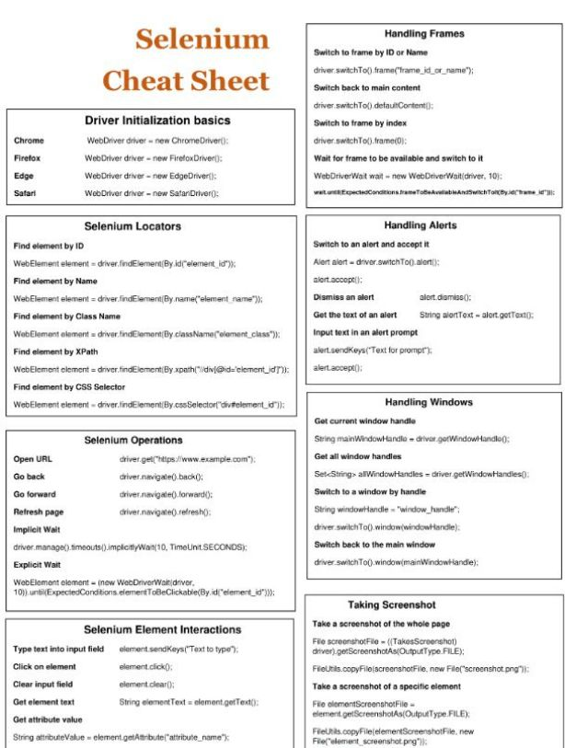

<?xml version="1.0" encoding="UTF-8"?>
<!DOCTYPE suite SYSTEM "https://testng.org/testng-1.0.dtd">
<suite name="Comptability Testing of Google" parallel="tests">
<test thread-count="5" name="Testing on Forefox">
<parameter name="browser" value="firefox"></parameter>
<classes>
<class name="ab53testng.launchingBrowser"/>
</classes>
</test> <!-- Test -->

<test thread-count="5" name="Testing on Edge">
<parameter name="browser" value="edge"></parameter>
<classes>
<class name="ab53testng.launchingBrowser"/>
</classes>
</test> <!-- Test -->

<test thread-count="5" name="Testing on Chrome">
<parameter name="browser" value="chrome"></parameter>
<classes>
<class name="ab53testng.launchingBrowser"/>
</classes>
</test> <!-- Test -->

</suite> <!-- Suite -->

